Testing Document

1.1.1

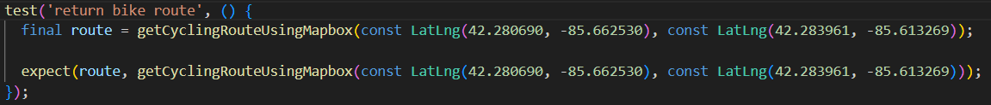

1.1.2

1.4.1

1.4.1

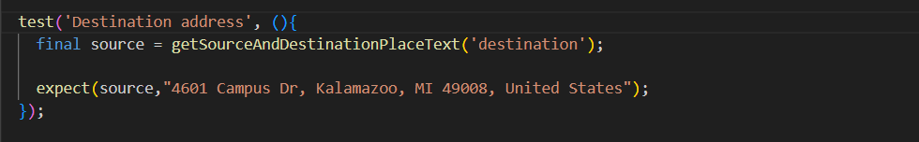

1.5.4

